**Abstract Class Lab**

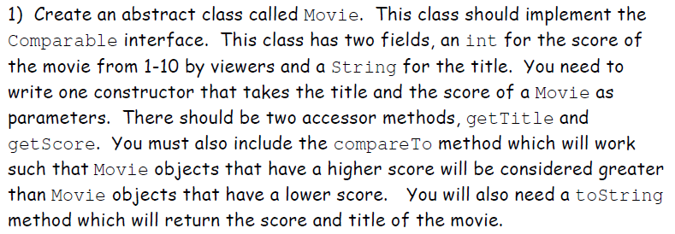

Finally, you need **an abstract method called getGenre(),** that has no parameters and returns a String.

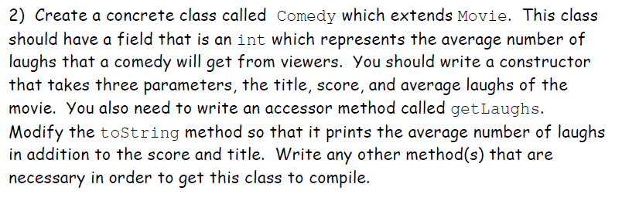

3) Make another class that extends Movie such as SciFiMovie. This class should have a field that is a double between 4.0 and 10.0 which represents the level of complexity of the plot. You should have a constructor that takes three parameters: the title, score, and level of complexity. You also need to write an accessor method get level, modify toString to show all the necessary information. Add any other method(s) that are necessary in order to get this class to compile.

4) Create a concrete class called MovieTrilogy which extends Movie. The classs hould have a constructor that takes three parameters: three Movie objects. Its title is the three movie titles separated by slashes. Its rating is the average of the three ratings. If all of this MovieTrilogy’s Movie objects have the same genre, its genre is Trilogy (Genre). Otherwise, the genre is Trilogy. Write or override any other method(s) that are necessary in order to get this class to compile and work properly.

5) Testing:

* create Comedy c = new Comedy(…
* create Movie m = new Comedy(…
* test methods getLaughs, getGenre, toString, compareTo for both objects
* create MovieTrilogy t = new MovieTrilogy(…
* create Movie m = new MovieTrilogy(…
* test methods getTitle, getScore
* test methods getGenre and toString with movies of the same and different genres